Epidemiology report

World Health Organization
WHO Test Laboratory

October 25, 2023
Table of contents
1. Data volume 3
2. Patient and sample details 4
2.1 Patient demographics 4
2.2 Location details 4
2.3 Sample details 5
3. Organism statistics 6
3.1 Organism frequencies 6
3.2 Organism frequencies by specimen categories 6
3.3 Organism trends 7
4. Antimicrobial statistics 9
4.1 Gram-positive and Gram-negative antibiograms 9
4.2 Isolate alerts - Important resistance 9
4.3 Multidrug resistance: ECDC definitions of MDR/XDR/PDR 9
4.4 Multidrug resistance: Resistance profiles 10
5. Reporting to the World Health Organization and the United Nations 12
5.1 WHO Global Priority List of Antibiotic-Resistant Bacteria 12
5.2 WHO GLASS results 12
5.3 United Nations Sustainable Development Goals 13
6. Cluster detection 14
6.1 Cluster detection by species 14
6.2 Cluster detection by resistance profile 15
Appendix A. Antibiograms 17

1. Data volume
Documenting the volume of testing performed by a laboratory is useful for monitoring changes in sampling practices over time and for comparing the workloads between laboratories. One may also identify time periods where data entry is incomplete, and many laboratories experienced a significant decrease in bacteriological testing in April 2020 with the arrival of COVID-19.
Some laboratories enter all bacteriological results into WHONET, whereas other only enter the results for positive samples. Some laboratories enter the results from other laboratory sections, including mycology, parasitology, and virology.
The below table and figure present the number of isolate records and the number of patients over time.

Laboratory | Number of isolates | Number of patients | Isolates per patient | 2000
TST | 622 | 277 | 2.2 | 277
Table 1: The number of isolates and patients by laboratory over time. For each time period, the numbers indicate the number of patient records, including negative results.
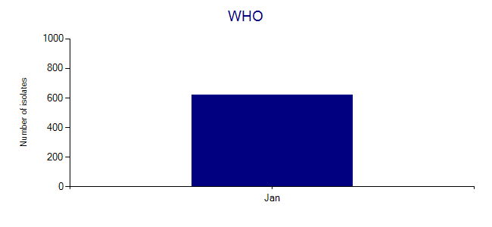
Figure 1: The distribution of isolates over time, including negative results.
The table includes the average number of isolate records per patient. This metric quantifies how often patients have multiple samples taken over time. In low-resource settings, this number is typically between 1.1 and 1.5 isolates per patient. A lower number may indicate that there are few patients with multiple samples, but it may also suggest that there are no meaningful identification numbers that can be used to track patients over time. A higher number may suggest one of two problems: 1) identification numbers are reused for different patients over time; or 2) there may be a problem in the data export from a laboratory information system or in the BacLink configuration.

2. Patient and sample details

2.1 Patient demographics
The distribution of patients by sex and age group is displayed in the below figures.
- Sex: Male - 47.1%, Female - 52.9%
  - In many countries, the number of isolates from female patients exceeds the number of isolates from male patients for a number of reasons: 1) a large proportion of laboratory samples are often from urinary tract infections in women; 2) women may seek medical assistance more frequently than men; and 3) in many countries, women have a longer lifespan than men.
- Median age group: Male = 25-34, Female = 25-34
  - The age distribution will reflect the patient population served by the laboratory.
The age distribution will reflect the patient population served by the laboratory.
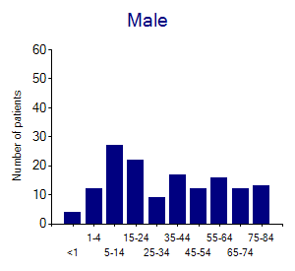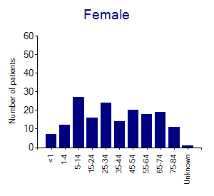
Figure 2: Distribution of the number of patients by sex and age group

2.2 Location details
The distributions of patients by top ten "location" and "location type" are displayed below. The location generally refers to the specific location where samples are collected, such as "Neurology", "Diabetes clinic", or the name of a town, farm, restaurant, or environmental site.
Location type is a category of location such as "inpatient", "outpatient", "farm", "restaurant", or "river". The use of standard WHONET codes is recommended to facilitate comparison of results between laboratories, but this is not required.

Location | Number of isolates | (%) | Number of patients | Isolates per patient
Outpatient | 124 | 19.9 | 99 | 1.3
Emergency room | 85 | 13.7 | 69 | 1.2
Oncology | 68 | 10.9 | 49 | 1.4
Medicine 1 | 59 | 9.5 | 48 | 1.2
Intensive care unit 1 | 52 | 8.4 | 44 | 1.2
Cardiac | 50 | 8 | 45 | 1.1
Cardiac surgery | 44 | 7.1 | 40 | 1.1
Neurology | 42 | 6.8 | 36 | 1.2
Infectious diseases | 37 | 5.9 | 31 | 1.2
Medicine 2 | 26 | 4.2 | 24 | 1.1
Table 2: The distribution of isolates and patients by location. The location codes are those used by the laboratory to identify the specimen collection site.

Location type | Number of isolates | (%) | Number of patients | Isolates per patient
inx | 328 | 52.7 | 196 | 1.7
out | 123 | 19.8 | 98 | 1.3
eme | 85 | 13.7 | 69 | 1.2
icu | 81 | 13 | 66 | 1.2
oth | 5 | 0.8 | 5 | 1
Table 3: The distribution of isolates and patients by location type. The user of standard WHONET location types is recommended to facilitate comparisons with other laboratories, but is not required.

2.3 Sample details
As displayed in the below figure, WHONET specimen types can be grouped into eight broad categories: Blood, Genital, Respiratory, Soft tissue and body fluids, Stool, Urine, Other, and Unknown.
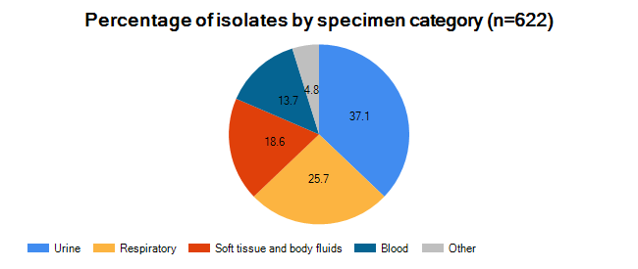
Figure 3: The figure shows the percentage of isolates stratified by specimen category.

3. Organism statistics

3.1 Organism frequencies
The most common use of WHONET is for bacterial results. However, WHONET can be used to manage results from other pathogens. The below table summarizes results according to organism type.

Organism type | Number of isolates | (%) | Number of patients | Isolates per patient
Aerobic Gram-positive bacteria | 334 | 53.7 | 197 | 1.7
Aerobic Gram-negative bacteria | 287 | 46.1 | 180 | 1.6
Other results | 1 | 0.2 | 1 | 1
Table 4: Distribution of results by organism type.
* Negative results: This category includes findings such as "No growth", "No enteric pathogens found", "Normal flora", and "Mixed bacterial species present".
The below table displays the most frequent results and the average number of isolates per patient. For community pathogens, this average number of isolates per patient is usually low, for example less than 1.2. For hospital pathogens, the average number of isolates per patient is often much higher, especially in intensive care units.

Organism | Code | Number of isolates | (%) | Number of patients | Isolates per patient
Staphylococcus, coagulase negative | scn | 105 | 16.9 | 82 | 1.3
Escherichia coli | eco | 86 | 13.8 | 71 | 1.2
Staphylococcus aureus | sau | 86 | 13.8 | 76 | 1.1
Enterococcus sp. | ent | 81 | 13 | 67 | 1.2
Pseudomonas aeruginosa | pae | 32 | 5.1 | 31 | 1
Haemophilus influenzae | hin | 24 | 3.9 | 24 | 1
Klebsiella pneumoniae | kpn | 23 | 3.7 | 23 | 1
Proteus mirabilis | pmi | 22 | 3.5 | 18 | 1.2
Corynebacterium sp. (diphtheroids) | cdp | 21 | 3.4 | 19 | 1.1
Streptococcus viridans, alpha-hem. | svi | 18 | 2.9 | 16 | 1.1
Table 5: The distribution of the most common organism results.
The below table summarizes WHONET’s alerts for "important species". Such pathogens are typically of public health importance because of their potential for outbreaks. They are often included in national disease control programs.

Organisms | Number of isolates | Priority
Neisseria meningitidis | 2 | High priority
Bordetella bronchiseptica | 4 | Medium priority
Pseudomonas aeruginosa | 32 | Medium priority
Pseudomonas fluorescens | 4 | Medium priority
Stenotrophomonas maltophilia | 10 | Medium priority
Table 6: Public health alerts - important species

3.2 Organism frequencies by specimen categories
The below figures display the most frequent results by specimen category. The most common pathogens are listed below by category.

Specimen category | Most common organism (%)
Blood | Staphylococcus, coagulase negative - (48%)
Other | Staphylococcus aureus ss. aureus - (27%)
Respiratory | Staphylococcus aureus ss. aureus - (19%)
Soft tissue and body fluids | Staphylococcus, coagulase negative - (27%)
Urine | Escherichia coli - (25%)

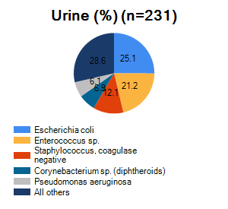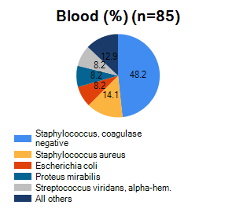
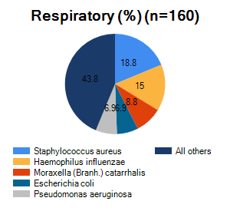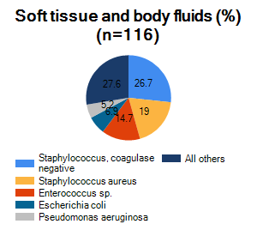
Figure 4: Most common organisms by specimen category. Numbers represent the percentage of isolates.

3.3 Organism trends
It is valuable to study changes in organism isolation over time. Organism frequencies depend on several factors.
The frequency of organisms seen in a microbiology laboratory may change over time for different reasons.
- Microbial factors
  - Long-term changes in organism epidemiology related to organism dissemination, virulence factors, and disease prevention measures such as vaccination and improved sanitation
  - Short-term changes suggestive of disease outbreaks. Statistical algorithms for automated outbreak detection are described in a separate section.
- Non-microbial factors
  - Healthcare services provided and patient populations
  - Sampling practices
  - Laboratory capacity and practices for organism identification
A simple way to look for long-term changes is with simple linear regression of organism counts over time, as shown in the below table.
No results found
Table 7: Organisms with statistically significant increases in organism frequency over time using simple linear regression. p<0.05 - The slope indicates that estimated change in the number of patients by quarter.
No results found
Table 8: Organisms with statistically significant decreases in organism frequency over time using simple linear regression. p<0.05 - The slope indicates that estimated change in the number of patients by quarter.

4. Antimicrobial statistics

4.1 Gram-positive and Gram-negative antibiograms
Appendix A contains the cumulative antimicrobial susceptibility test statistics for Gram-positive and Gram-negative bacteria, typically known as an "antibiogram". The number of isolates tested is greater than or equal to 20. The official recommendation from the CLSI M39 document and others is at least 30 isolates, but a limit of 20 is still useful, especially in a low-resource setting with smaller data volumes and for organisms of clinical importance.
Policymakers must be very aware of problems in laboratory test quality and different types of bias due to patient presentation, sampling practices, and laboratory test practices. Routine microbiology laboratory data typically underestimates the incidence of microbial disease but overestimates the proportion of resistance.

4.2 Isolate alerts - Important resistance
The below table summarizes WHONET’s high- and medium-priority "important resistance" alerts. The findings should be confirmed to ensure that there is no error in the organism identification or in the antimicrobial susceptibility test.
WHO has defined a "Global Priority List of Antimicrobial Resistant Bacteria". These are summarized in a separate section.

Organisms | Alert | Number of isolates | Priority
Enterobacteriaceae | Carbapenems = Non-susceptible | 31 | High priority
Streptococcus sp. | Vancomycin or Teicoplanin = Non-susceptible | 1 | High priority
Streptococcus, beta-hemolytic | Penicillins = Non-susceptible | 3 | High priority
Enterobacteriaceae | Amikacin = Non-susceptible | 5 | Medium priority
Enterobacteriaceae | Possible ESBL-producing Enterobacteriaceae | 9 | Medium priority
Enterococcus sp. | Vancomycin-resistant Enterococcus | 11 | Medium priority
Staphylococcus aureus | Methicillin-resistant Staphylococcus aureus | 10 | Medium priority
Table 9: Public health alerts - important resistance

4.3 Multidrug resistance: ECDC definitions of MDR/XDR/PDR
In a 2012 publication, the European Centre for Disease Prevention and Control (ECDC) proposed definitions for common bacterial pathogens resistant to multiple antimicrobials. MDR/XDR/PDR results are summarized in the below table.
- MDR Multidrug resistance
- XDR Extensive drug resistance
- PDR Pan-drug resistance

Organism | Number of isolates | MDR | Possible XDR | Possible PDR
Enterococcus faecalis | 1
Staphylococcus aureus | 86 | 13 (15%) | 9 (10%) | 4 (5%)
Acinetobacter sp. | 8 | 1 (13%)
Escherichia coli | 86 | 4 (5%)
Klebsiella pneumoniae | 23
Pseudomonas aeruginosa | 32 | 2 (6%) | 2 (6%)
Table 10: MDR, XDR, PDR summary

4.4 Multidrug resistance: Resistance profiles
One of the most valuable, but least utilized, analyses in WHONET is "resistance profiles" for studying multidrug resistance. The study of multidrug resistance has several applications:
- Phenotypic strain tracking facilitates the monitoring of distinct microbial subpopulations, greatly improving the recognition of 1) new strains; and 2) hospital and community outbreaks. Clusters identified by phenotypic tracking could be investigated by molecular typing to confirm clonality.
- The study of cross-resistance is useful in the development of treatment guidelines, including: 1) the determination of recommended "first-line" and "second-line" treatment options; and 2) estimating the value of combination therapy on local pathogens.
- Predicting resistance mechanisms based on the results from antimicrobials within a specific antimicrobial class or subclass or related classes.
- Exploring potential errors in laboratory test practices, for example the finding of isolates of Escherichia coli susceptible to ampicillin but resistant to imipenem is unlikely, and may be due to a testing error, for example with imipenem disks that have lost their disk potency.
In a section on "Antimicrobial susceptibility test practices", a set of "core antimicrobials" for Staphylococcus aureus and Escherichia coli has been proposed based on the data analyzed in this report. The below tables use these core antimicrobials to create resistance profiles. The tables only include isolates that were tested against all core antimicrobials.
Organism | Number of antibiotics | Core antibiotics | Number of isolates tested against all antimicrobials (%)
Staphylococcus aureus | 7 | Penicillin G, Erythromycin, Clindamycin, Cefoxitin, Gentamicin, Trimethoprim/Sulfamethoxazole, Ciprofloxacin | 86/86 (100%)
Escherichia coli | 7 | Ampicillin, Gentamicin, Trimethoprim/Sulfamethoxazole, Cefotaxime, Imipenem, Cefuroxime, Aztreonam | 85/86 (99%)

Resistance profile | Number of isolates | %Isolates | Number of patients
PEN | 27 | 31.4 | 26
PEN ERY | 19 | 22.1 | 19
(Susceptible) | 10 | 11.6 | 10
PEN ERY CIP | 6 | 7 | 6
ERY | 4 | 4.7 | 4
ERY CIP | 4 | 4.7 | 4
PEN ERY CLI FOX GEN SXT CIP | 4 | 4.7 | 4
PEN CIP | 3 | 3.5 | 3
PEN ERY CLI FOX CIP | 3 | 3.5 | 3
PEN ERY CLI CIP | 2 | 2.3 | 2
Table 11: Multi-drug resistance profiles for Staphylococcus aureus

Resistance profile | Number of isolates | %Isolates | Number of patients
(Susceptible) | 48 | 56.5 | 44
AMP | 16 | 18.8 | 14
GEN | 6 | 7.1 | 6
AMP SXT | 4 | 4.7 | 4
CTX | 2 | 2.4 | 2
SXT | 2 | 2.4 | 2
AMP CXM | 2 | 2.4 | 2
AMP CTX CXM | 2 | 2.4 | 2
AMP GEN | 1 | 1.2 | 1
AMP GEN SXT | 1 | 1.2 | 1
Table 12: Multi-drug resistance profiles for Escherichia coli

5. Reporting to the World Health Organization and the United Nations

5.1 WHO Global Priority List of Antibiotic-Resistant Bacteria
Priority | Organism | Antibiotic results | Number (%)
Critical | Acinetobacter spp. | Carbapenem resistance | -
 | Pseudomonas aeruginosa | Carbapenem resistance | -
 | Escherichia coli | Cefotaxime-resistant | 0/70 (0%)
 | Escherichia coli | Ceftriaxone-resistant | -
 | Escherichia coli | Meropenem-resistant | -
High | Enterococcus faecium | Vancomycin-resistant | -
 | Staphylococcus aureus | Methicillin-resistant (MRSA) | 8/76 (11%)
 | Staphylococcus aureus | Vancomycin-resistant | 0/76 (0%)
 | Staphylococcus aureus | Vancomycin-intermediate | 0/76 (0%)
 | Helicobacter pylori | Clarithromycin-resistant | -
 | Campylobacter spp. | Fluoroquinolone-resistant | -
 | Salmonella spp. | Fluoroquinolone-resistant (Ciprofloxacin) | -
 | Neisseria gonorrhoeae | Third generation cephalosporin-resistant | -
 | Neisseria gonorrhoeae | Fluoroquinolone-resistant | -
Medium | Streptococcus pneumoniae | Penicillin non-susceptible | -
 | Haemophilus influenzae | Ampicillin-resistant | 8/24 (33%)
 | Shigella spp. | Fluoroquinolone-resistant | -
Table 13: WHO Global priority list of antibiotic-resistant bacteria

5.2 WHO GLASS results
The WHO Global Antimicrobial Resistance Surveillance System (GLASS) collects annual data on specific antimicrobials from eight pathogens from four specimen types. Two of the GLASS statistics have been selected as indicators for the United Nations Sustainable Development Goals.
Specimen type | Organisms
Blood | Staphylococcus aureus, Streptococcus pneumoniae, Escherichia coli, Klebsiella pneumoniae, Acinetobacter spp., Salmonella spp.
Urine | Escherichia coli, Klebsiella pneumoniae
Stool | Salmonella spp., Shigella spp.
Genital | Neisseria gonorrhoeae

The below tables present the statistics for the number of patients with the samples, organisms, and antibiotics requested by the WHO GLASS protocol.

Specimen | Number of patients
BLOOD | 66
LOWRESP | 113
PHARYNGEAL | 5
URINE | 171
Table 14: The number of patients with the specimen types requested by WHO GLASS.

Specimen | Pathogen | Number of patients
BLOOD | ESCCOL | 6
BLOOD | KLEPNE | 2
BLOOD | STAAUR | 11
BLOOD | STRPNE | 5
LOWRESP | ACISPP | 1
LOWRESP | ESCCOL | 10
LOWRESP | HAEINF | 24
LOWRESP | KLEPNE | 5
LOWRESP | PSEAER | 11
LOWRESP | STAAUR | 24
LOWRESP | STRPNE | 1
URINE | ESCCOL | 51
URINE | KLEPNE | 12
Table 15: The number of patients with the specimen types and organisms requested by WHO GLASS.

Specimen | Pathogen | Antibiotic | Number of patients | Number tested | %Resistant | %Intermediate | %Susceptible
LOWRESP | HAEINF | AMC | 24 | 24 |  |  | 100
LOWRESP | HAEINF | AMP | 24 | 24 | 33.3 | 4.2 | 62.5
LOWRESP | HAEINF | CIP | 24 | 24 |  |  | 100
LOWRESP | HAEINF | CTX | 24 | 24 |  |  | 100
LOWRESP | HAEINF | SXT | 24 | 24 | 4.2 |  | 95.8
LOWRESP | STAAUR | FOX | 24 | 24 | 16.7 |  | 83.3
URINE | ESCCOL | CTX | 51 | 50 |  | 4 | 96
URINE | ESCCOL | IPM | 51 | 50 |  |  | 100
URINE | ESCCOL | NIT | 51 | 50 |  | 4 | 96
URINE | ESCCOL | SXT | 51 | 50 | 8 |  | 92
Table 16: The number of patients and antimicrobial statistics for the specimen types, organisms, and antimicrobials requested by WHO GLASS.

5.3 United Nations Sustainable Development Goals
The United Nations has selected two of the above metrics as indicators for the United Nations Sustainable Developments Goals.
SDG 3.d.2: Percentage of bloodstream infection due to methicillin-resistant Staphylococcus aureus (MRSA) and Escherichia coli resistant to 3rd-generation cephalosporin (e.g., ESBL- E. coli) among patients seeking care and whose blood sample is taken and tested.
- % Methicillin-resistant Staphylococcus aureus in blood (Oxacillin): No results found
- % Methicillin-resistant Staphylococcus aureus in blood (Cefoxitin): Insufficient data
- % Third-generation cephalosporin-resistance Escherichia coli in blood: No results found

6. Cluster detection
It is possible to find statistically significant "case clusters" from routine microbiology laboratory data using mathematical algorithms, such as those offered by the free SaTScan software, SaTScan.org. The most valuable use of these approaches is to find possible community and hospital infectious disease outbreaks. However, the data analyst must keep in mind that there are both "outbreak" and "pseudo-outbreak" explanations for statistically significant case clusters.
- True infectious disease outbreak
- Changes in patient identification and sampling practices
- Changes in laboratory testing practices
- Contamination rates of clinical samples
- Deficiencies in laboratory reagents leading to incorrect results
- Variable availability of laboratory reagents leading to variability capabilities
- Variable completeness and practices for data entry
Ultimately, these algorithms cannot make the definitive ascertainment that certain findings represent a true disease outbreak. Rather, the goal is to use laboratory data to identify statistical findings that merit further investigation and possible response by infection control staff for possible hospital breakpoints and public health authorities for possible community outbreaks.
One must also keep in mind that statistical algorithms applied to microbiology laboratory data may not be able to find all outbreaks.
- Many patients involved in an outbreak do not have diagnostic samples taken because they are asymptomatic or have mild symptoms or because there is limited capacity and resources to support sample collection and laboratory testing.
- Small patient numbers and slowly developing clusters may be indistinguishable for baseline random variation.
- The cluster detection algorithm model and algorithm parameters may be poorly optimized for detecting certain types of cluster curves.

6.1 Cluster detection by species
Using "Organism" as the cluster detection variable, the below figures display a number of statistically significant case clusters.

Cluster description | Cluster start date | Cluster end date | p-value - Lowest | Number observed - Total | Total days in cluster
TST - Corynebacterium sp. (diphtheroids) | 25/1/2000 | 25/1/2000 | 0.00689 | 7 | 1
TST - Klebsiella pneumoniae | 28/1/2000 | 30/1/2000 | 0.021 | 10 | 3
Table 17: Cluster detection by species
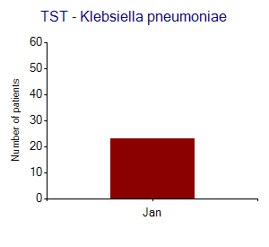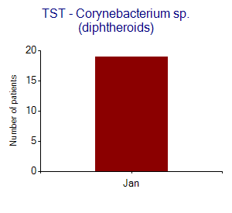
Figure 5: Statistically significant case clusters detected by organism identification (p <= 0.05). The monthly count of patients is presented, and the statistically significant time period detected by SaTScan is indicated in red.

6.2 Cluster detection by resistance profile
The above examples illustrate an approach to cluster detection using the "organism" name. This can be further extended to include cluster detection by geographic location, by hospital ward, by resistance profile, and also be combinations of variables, such as "location + resistance profile". For example, Figure 7 displays statistically significant clusters of phenotypic subpopulations of Escherichia coli defined by the multidrug resistance profile. Each letter represents a particular antimicrobial.

Cluster description | Cluster start date | Cluster end date | p-value - Lowest | Number observed - Total | Total days in cluster
TST:ERY | 22/1/2000 | 22/1/2000 | 0.000934 | 4 | 1
Table 18: Cluster detection for Staphylococcus aureus detected by resistance profile.
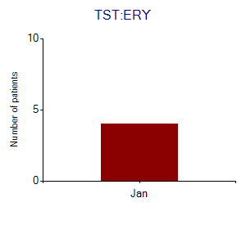
Figure 6: Statistically significant case clusters of Staphylococcus aureus detected by resistance profile (p <= 0.05). The weekly count of patients is presented, and the statistically significant time period detected by SaTScan is indicated in red.
No results found
Table 19: Cluster detection for Escherichia coli detected by resistance profile.
No results found
Figure 7: Statistically significant case clusters of Escherichia coli detected by resistance profile (p <= Not applicable). The weekly count of patients is presented, and the statistically significant time period detected by SaTScan is indicated in red.

Appendix A. Antibiograms

Organism | Number of patients | AMC | AMP | FOX | CIP | CLI | ERY | GEN | NIT | OXA | PEN | SXT | VAN
Staphylococcus, coagulase negative | 82 | 39 |  |  | 66 | 77 | 46 | 79 | 91 | 39 | 17 | 60
Staphylococcus aureus | 76 |  |  | 90 | 75 | 86 | 45 | 95 |  |  | 20 | 95
Enterococcus sp. | 67 |  | 88 |  |  |  | 14 | 60 | 90 |  | 85 |  | 85
Table 20: Gram-positive antibiogram. %Susceptible, first isolate per patient

Code | Antibiotic | Code | Antibiotic | Code | Antibiotic
AMC | Amoxicillin/Clavulanic acid | CLI | Clindamycin | OXA | Oxacillin
AMP | Ampicillin | ERY | Erythromycin | PEN | Penicillin G
FOX | Cefoxitin | GEN | Gentamicin | SXT | Trimethoprim/Sulfamethoxazole
CIP | Ciprofloxacin | NIT | Nitrofurantoin | VAN | Vancomycin
Table 21: Gram-positive antibiotics.

Organism | Number of patients | AMK | AMC | AMP | ATM | CTX | FOX | CAZ | CXM | CHL | CIP | GEN | IPM | NIT | NOR | TOB | SXT
Escherichia coli | 71 |  | 84 | 70 | 99 | 93 | 76 |  | 93 |  | 76 | 89 | 99 | 96 | 100 |  | 93
Pseudomonas aeruginosa | 31 | 97 |  |  | 81 |  |  | 100 |  | 6 | 77 | 87 | 94 |  |  | 90 | 6
Haemophilus influenzae | 24 |  | 100 | 62 |  | 100 |  |  | 100 |  | 100 |  | 100 |  |  |  | 96
Klebsiella pneumoniae | 23 |  |  | 9 | 100 | 96 |  |  | 100 |  |  | 91 | 96 |  |  |  | 96
Table 22: Gram-negative antibiogram. %Susceptible, first isolate per patient

Code | Antibiotic | Code | Antibiotic | Code | Antibiotic
AMK | Amikacin | CAZ | Ceftazidime | NIT | Nitrofurantoin
AMC | Amoxicillin/Clavulanic acid | CXM | Cefuroxime | NOR | Norfloxacin
AMP | Ampicillin | CHL | Chloramphenicol | TOB | Tobramycin
ATM | Aztreonam | CIP | Ciprofloxacin | SXT | Trimethoprim/Sulfamethoxazole
CTX | Cefotaxime | GEN | Gentamicin
FOX | Cefoxitin | IPM | Imipenem
Table 23: Gram-negative antibiotics.

